BASIC STATS 2

1. **Build 99% Confidence Interval Using Sample Standard Deviation**
2. *Calculate Sample Mean*

X̄ = 1.13 + 1.55 + 1.43 + 0.92 + 1.25 + 1.36 + 1.32 + 0.85 + 1.07+ 1.48 + 1.20 + 1.33 / 15

X̄ = 1.036

1. *Calculate Sample Standard Deviation*

​ 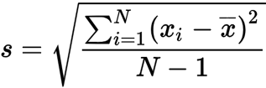

s = $\sqrt{{(1.13 - 1.036)2 }^{} + (1.55 - 1.036)2 + (0.92- 1.036)2 + (1.25 - 1.036)2 + ...+(1.29 - 1.036)2 }÷ 14$

s $=$ 0.231

1. *T Value For 99% Confidence Interval*

Degree of freedom (df) = n -1

= 15 - 1 = 14

$α = 1 - 0.99 = 0.01$

Now using t calculator,

${ t}_{0.005,14 }$ $= 2.977$

1. *Calculate Margin Of Error*

ME = t $× \frac{s}{\sqrt{n}}$

= 2.977 $× \frac{0.231}{\sqrt{15}}$

$= 0.116$

1. *Confidence Interval*

= $\underline{(x } - ME) to (\underline{x } + ME$)

= (1.036 - 0.116) to (1.036 + 0.116)

= 0.920 to 1.152

### REASON FOR USING THE t-DISTRIBUTION

**The sample size (n = 15) is small and population std is unknown.**

**2. Build 99% Confidence Interval Using Known Population Standard Deviation**

1. *Calculate Sample Mean*
$\underline{x } = 1.036$

2. *Calculate Population Standard Deviation*

$σ = 0.2$

1. *Z Value For 99% Confidence Interval*

$Z_{0.005 } ≈ 2.576$

1. *Calculate Margin Of Error*

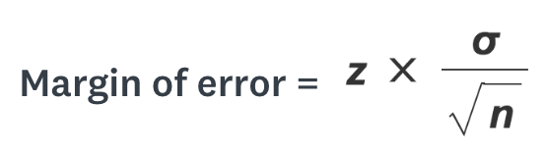

n = 15,

ME = 2.576 $× \frac{0.2}{\sqrt{15}}$

ME $≈ 0.133$

1. *Confidence Interval*

= $\underline{(x } - ME) to (\underline{x } + ME$)

= (1.036 - 0.133) to (1.036 + 0.133)

= 0.903 to 1.169